Charles Dvorak
Jack O’Connor
Richard Bump
Sam Witham
IST 707 – Data Analytics
Final Report
3.20.2020
A Study to identify if advanced data modeling can be utilized to provide an advantage to the New York Mets Pitching Staff.
Analytical REview of New York Mets Pitching Staff

Introduction

Until the Oakland Athletics made analytics famous, baseball use of analytics was limited to descriptive statistics. You measured hitters by their batting average, home runs, and runs batted in (RBIs). You evaluated pitchers based on their record, their earned run average (ERA), and their number of strikeouts. Each of these statistics had thresholds that if you met, you were looked at as a good player. For batters it was a .300 batting average, 40 homeruns, or 100 RBIs. For a pitcher, it was 20 wins, less than a 2.50 earn run average (ERA), or 300 strikeouts per year. Teams relied more on experience and the “eye” of their managers, and coaches to provide that advantage.

Today analytics is a much bigger part of the game. Most teams have entire analytical departments. While traditional statistics of the past are kept, these analytical departments focus more on how to provide their team with advantage while on the field. When on defense each player knows where to position themselves based on the opposing batter and the particular situation, count, and various other details. In fact, if you watch closely you can see players pull a card from their pocket referencing those analytics. As a pitcher, it’s all about “Spin Rate”. As a batter, you are not encouraged to focus on details like “Launch Angle”. In the past it was about putting the ball in play, now it is about making the most of each at bat. This approach has resulted in a lot more strikeouts for players. While in the past this was a negative, it isn’t viewed as much in that light today. This is just one change that advancements in analytics has caused on the game of baseball.

This report is going to take a look to see if advance data modeling can be used to identify key strengths and weaknesses in the New York Mets Pitching staff. Rather than providing an advantage the analytics will be directed towards Mets pitchers to see if other teams would be effective in using these analytics techniques against us. In particular, can classification models be used to predict what pitches will be thrown in specific situations.

Analysis and Models

About the Data

Description
The dataset reviewed came from “Baseball Savant”. This is the data that feeds “Stat Cast”, which has become an essential part of baseball broadcasts. The dataset consisted of every pitch from five preselected New York Mets Pitchers from 2017- 2019. This amounted to over thirty-thousand pitches, each with eighty-nine attributes each.

Variables

* Please Note that the description of the variables in either taken entirely or in part directly from the data source, “Baseball Savant part of Major League Baseball baseballsavant.mlb.com”
- “pitch_type”: A factor with 10 levels represented by a two letter designation indicating the type of pitch.
- “game_date”: A factor with 363 levels representing the date of the game.
- “release_speed”: The speed of the pitch registered as the pitcher releases the pitch.
- “release_pos_x”: The horizontal release position of the ball when it is released from the catcher view. Measured in feet.
- “release_pos_z”: The vertical release position of the ball when it is released from the catcher view. Measured in feet.
- “player_name”: Name of the pitcher throwing the pitch.
- “batter”: A unique number identifying the batter that is at the plate at the time of the pitch.
- “pitcher”: A unique number identifying the pitcher that throws each pitch.
- “events”: A Factor of 22 levels identifying what happened as a result of the pitch.
- “description”: A factor with 15 levels, shorthand of the result of the pitch.
- “spin_dir”: A historical field that did not provide any information for the years queried from the Baseball Savant Database. Used to track in formation prior to 2017.
- “spin_rate_deprecated”: A historical field that did not provide any information for the years queried from the Baseball Savant Database. Used to track in formation prior to 2017.
- “break_angle_deprecated”: A historical field that did not provide any information for the years queried from the Baseball Savant Database. Used to track in formation prior to 2017.
- “break_length_deprecated”: A historical field that did not provide any information for the years queried from the Baseball Savant Database. Used to track in formation prior to 2017.
- “zone”: A factor of 14 levels indicating the zone the pitch was in. 1-9 represents strikes, while 10-14 indicate that the pitch was identified as a ball if a computer was calling balls and strikes.
- “des”: A string of what happened as a result of the pitch, including additional details unique to the specific pitch.
- “game_type”: A factor with 1 level indicating the type of game. Only “regular season” games were used.
- “stand”: A factor with 2 level indicating the side of the plate the batter swung from.
- “p_throws”: A factor with 2 level indicating if the pitcher threw the pitch left handed or right handed.
- “home_team”: Indicates which team was home.
- “away_team”: Indicates which team was away.
- “type”: A factor with 3 levels indicating if the pitch was a ball, strike, or hit in play.
- “hit_location”: Indicates the position the ball was hit to, by the traditional number of each position.
- “bb_type”: A factor with 4 levels, indicating the Battled ball type (i.e. Ground Ball, Line Drive, Popup).
- “balls”: Indicates the number of balls in the count prior to the pitch.
- “strikes”: Indicates the number of strikes in the count prior to the pitch.
- “game_year”: Indicates the year of the game took place in
- “pfx_x”: Indicates the amount of feet that the pitch moved horizontally from the catcher’s perspective.
- “pfx_z”: Indicates the amount of feet that the pitch moved vertically from the catcher’s perspective.
- “plate_x”: Where the ball crosses the plate horizontally from catcher’s perspective.
- “plate_z”: Where the ball crosses the plate vertically from catcher’s perspective.
- “on_3b”: A unique number identifying the player that indicates the player (if any) on third base at the time of the pitch.
- “on_2b”: A unique number identifying the player that indicates the player (if any) on second base at the time of the pitch.
- “on_1b”: A unique number identifying the player that indicates the player (if any) on first base at the time of the pitch.
- “outs_when_up”: The number of outs prior to the pitch being thrown.
- “inning”: Inning that the pitch occurred in.
- “inning_topbot”: Indicates if it is the top or bottom of the inning.
- “hc_x”: Where the ball was hit (x coordinate).
- “hc_y”: Where the ball was hit (y coordinate).
- “tfs_deprecated”: A historical field that did not provide any information for the years queried from the Baseball Savant Database. Used to track in formation prior to 2017.
- “tfs_zulu_deprecated”: A historical field that did not provide any information for the years queried from the Baseball Savant Database. Used to track in formation prior to 2017.
- “fielder_2”: A unique number identifying the player at the catcher position at the time of the pitch.
- “umpire”: A historical field that did not provide any information for the years queried from the Baseball Savant Database. Used to track in formation prior to 2017.
- “sv_id”: Non-unique Id of play event per game.
- “vx0”: The velocity of the pitch, in feet per second, in x-dimension, determined at y=50 feet.
- “vy0”: The velocity of the pitch, in feet per second, in y-dimension, determined at y=50 feet.
- “vy0”: The velocity of the pitch, in feet per second, in z-dimension, determined at y=50 feet.
- “ax”: The acceleration of the pitch, in feet per second per second, in x-dimension, determined at y=50 feet.
- “ay”: The acceleration of the pitch, in feet per second per second, in y-dimension, determined at y=50 feet.
- “az”: The acceleration of the pitch, in feet per second per second, in z-dimension, determined at y=50 feet.
- “sz_top”: Top of the batter's strike zone set by the operator when the ball is halfway to the plate.
- “sz_bot”: Bottom of the batter's strike zone set by the operator when the ball is halfway to the plate.
- “hit_distance”: Projected hit distance of the batted ball.
- “launch_speed”: Exit velocity of the batted ball as tracked by Statcast. For the limited subset of batted balls not tracked directly, estimates are included based on the process described here.
- “launch_angle”: Launch angle of the batted ball as tracked by Statcast. For the limited subset of batted balls not tracked directly, estimates are included based on the process described here.
- “effective_speed”: Derived speed based on the the extension of the pitcher's release.
- “release_spin”: Spin rate of pitch tracked by Statcast.
- “release_extension”: Release extension of pitch in feet as tracked by Statcast.
- “game_pk”: Unique Id for Game.
- “pitcher”: MLB Player Id tied to the play event.
- “fielder_2”: MLB Player Id for catcher.
- “fielder_3”: MLB Player Id for 1B.
- “fielder_4”: MLB Player Id for 2B.
- “fielder_5”: MLB Player Id for 3B.
- “fielder_6”: MLB Player Id for SS.
- “fielder_7”: MLB Player Id for LF.
- “fielder_8”: MLB Player Id for CF.
- “fielder_9”: MLB Player Id for RF.
- “release_pos_y”: Release position of pitch measured in feet from the catcher's perspective.
- “estimated_ba_using_speedangle”: Estimated Batting Avg based on launch angle and exit velocity.
- “estimated_woba_using_speedangle”: Estimated wOBA based on launch angle and exit velocity.
- “woba_value”: wOBA value based on result of play.
- “woba_denom”: wOBA denominator based on result of play.
- “babip_value”: BABIP value based on result of play.
- “iso_value”: ISO value based on result of play.
- “launch_speed_angle”: Launch speed/angle zone based on launch angle and exit velocity.
1: Weak
2: Topped
3: Under
4: Flare/Burner
5: Solid Contact
6: Barrel
- “at_bat_number”: Plate appearance number of the game.
- “pitch_number”: Total pitch number of the plate appearance.
- “pitch_name”: The name of the pitch derived from the Statcast Data.
- “home_score”: Pre-pitch home score
- “away_score”: Pre-pitch away score
- “bat_score”: Pre-pitch bat team score
- “fld_score”: Pre-pitch field team score
- “post_home_score”: Post-pitch home score
- “post_away_score”: Post-pitch away score
- “post_bat_score”: Post-pitch bat team score
- “if_fielding_alignment”: Infield fielding alignment at the time of the pitch.
- “of_fielding_alignment”: Outfield fielding alignment at the time of the pitch.

Exploring the Data

Figure 1: Edwin Diaz’s Appearances

Figure 1: Visualizes the total number of appearances and total number of innings pitched by Edwin Diaz between 2017 and 2019.

Figure 2: Edwin Diaz’s Performance
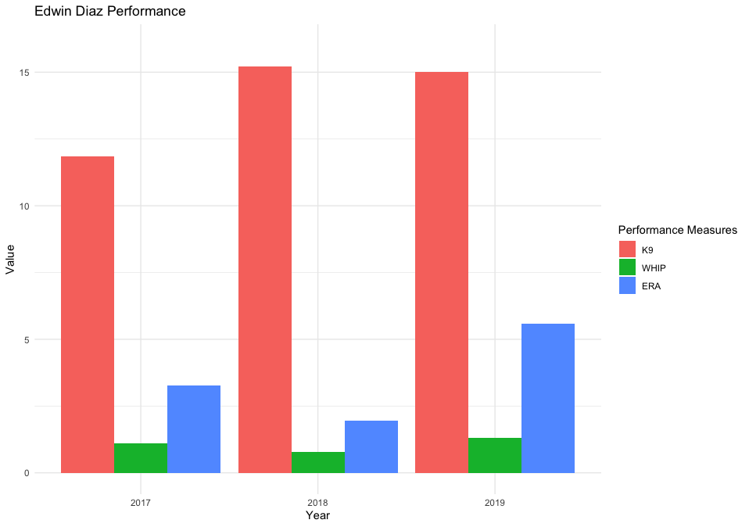
Figure 2: Visualizes the performance statistics including K/9, WHIP, and ERA for Edwin Diaz between 2017-2019

Figure 3: Edwin Diaz’s Pitch Breakdown
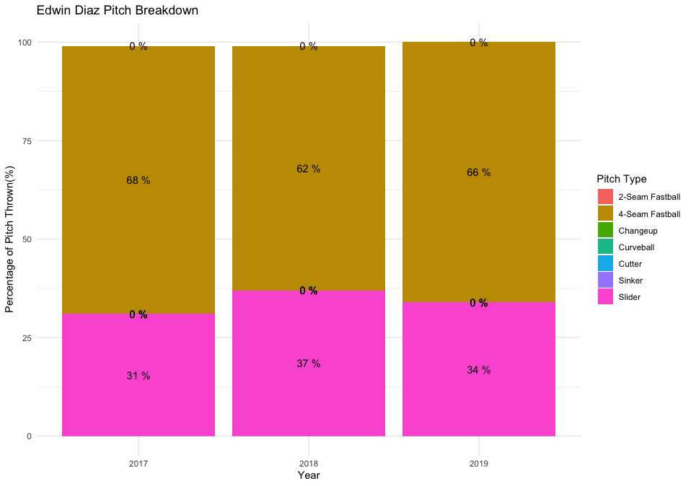
Figure 3: Visualizes the breakdown of pitches thrown by Edwin Diaz between 2017-2019

Figure 4: Edwin Diaz’s Win Lose Record
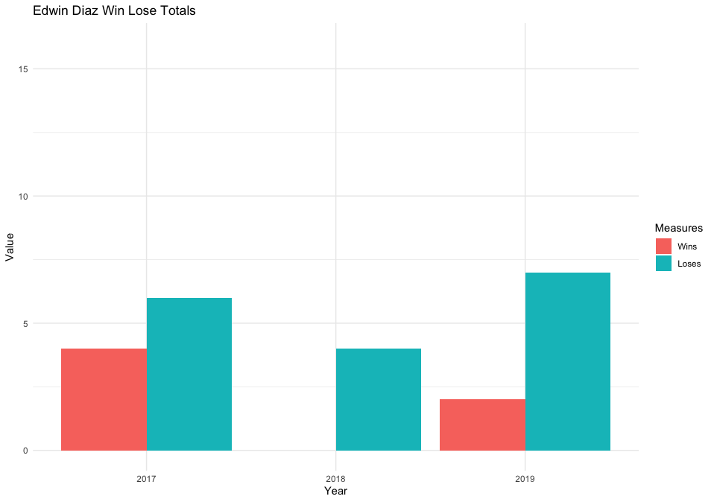
Figure 4: Visualizes the Win Lose Record for Edwin Diaz between 2017-2019

Figure 5: Jacob deGrom’s Appearances
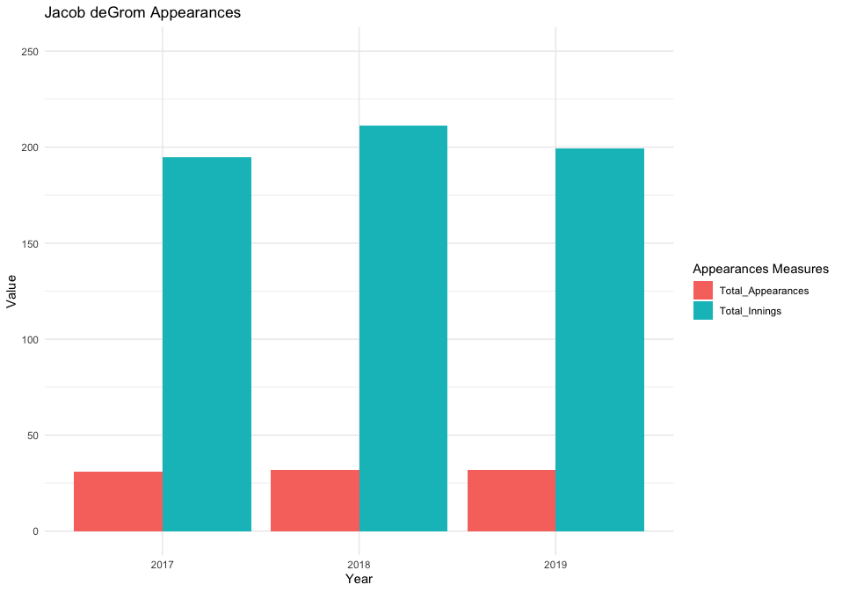
Figure 5: Visualizes the total number of appearances and total number of innings pitched by Jacob deGrom between 2017 and 2019.

Figure 6: Jacob deGrom’s Performance
Figure 6:
Figure 6: Visualizes the performance statistics including K/9, WHIP, and ERA for Jacob deGrom between 2017-2019

Figure 7: Jacob deGrom’s Pitch Breakdown
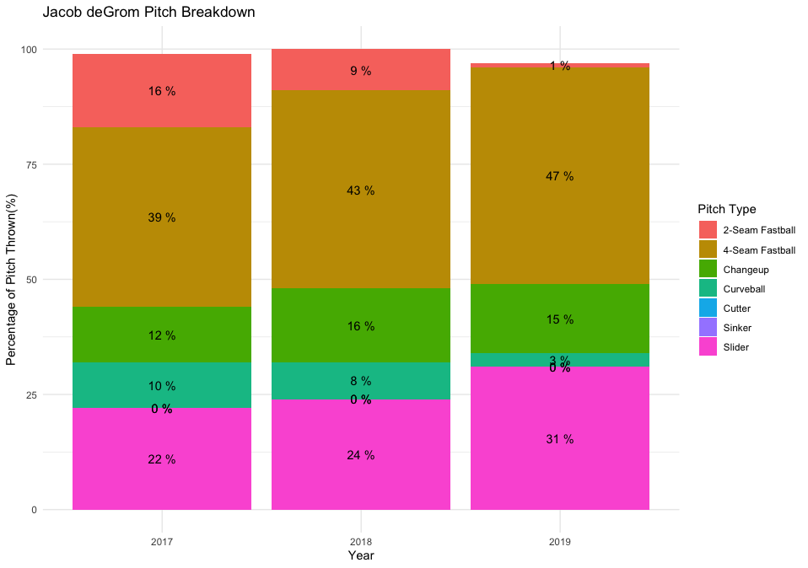
Figure 7: Visualizes the breakdown of pitches thrown by Jacob deGrom between 2017-2019

Figure 8: Jacob deGrom’s Win Lose Record
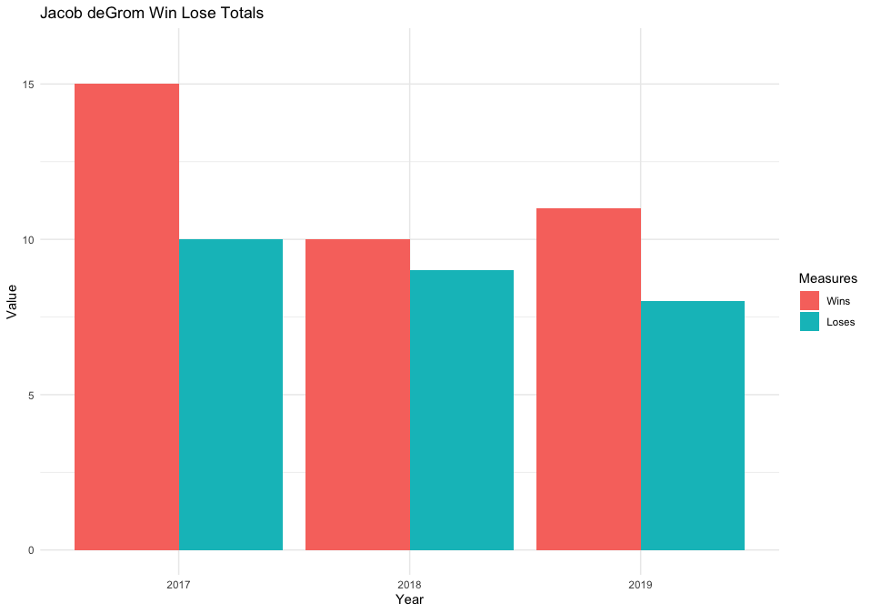
Figure 8: Visualizes the Win Lose Record for Jacob deGrom between 2017-2019

Figure 9: Marcus Stroman’s Appearances
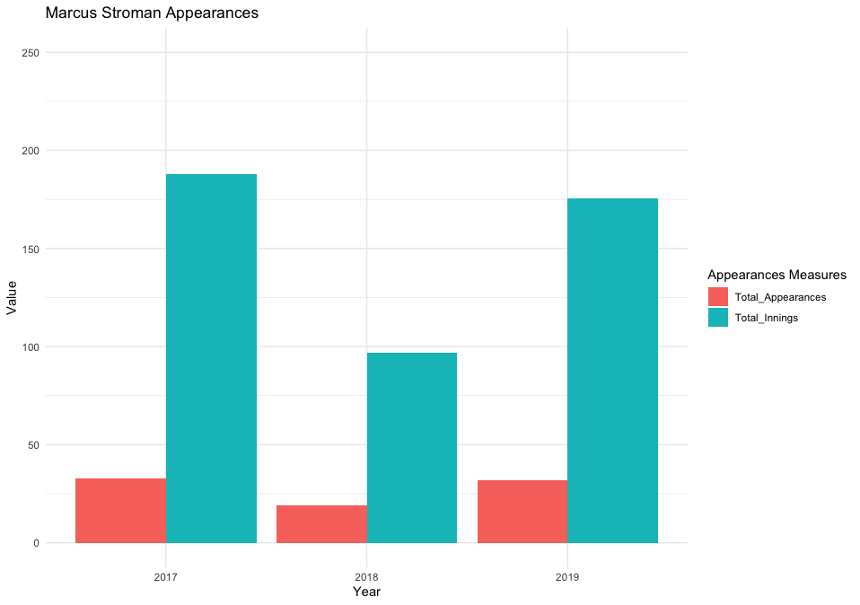
Figure 9: Visualizes the total number of appearances and total number of innings pitched by Marcus Stroman between 2017 and 2019.

Figure 10: Marcus Stroman’s Performance
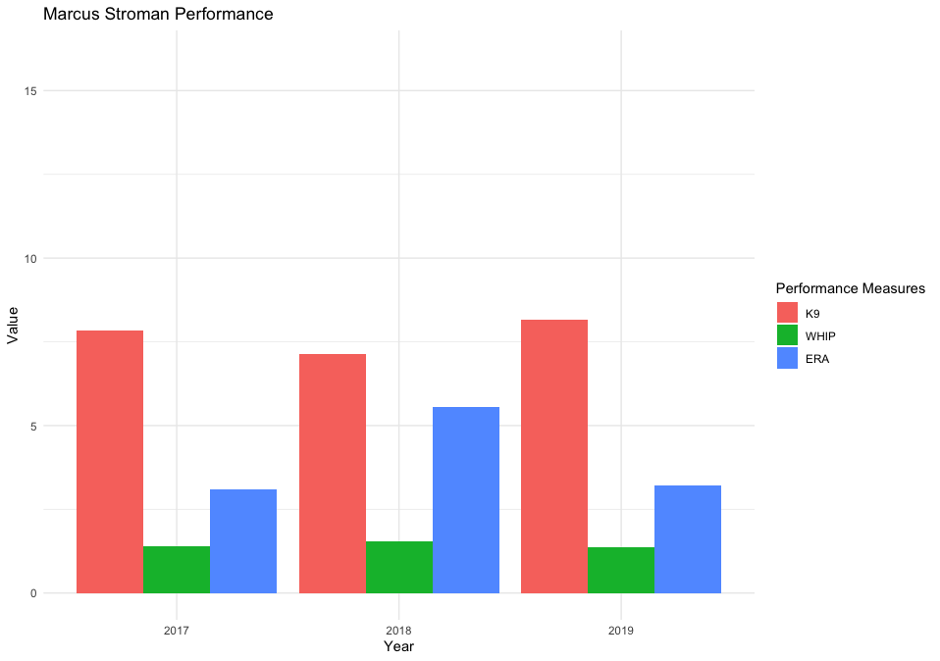
Figure 10: Visualizes the performance statistics including K/9, WHIP, and ERA for Marcus Stroman between 2017-2019

Figure 11: Marcus Stroman’s Pitch Breakdown

Figure 11: Visualizes the breakdown of pitches thrown by Marcus Stroman between 2017-2019

Figure 12: Marcus Stroman’s Win Lose Record
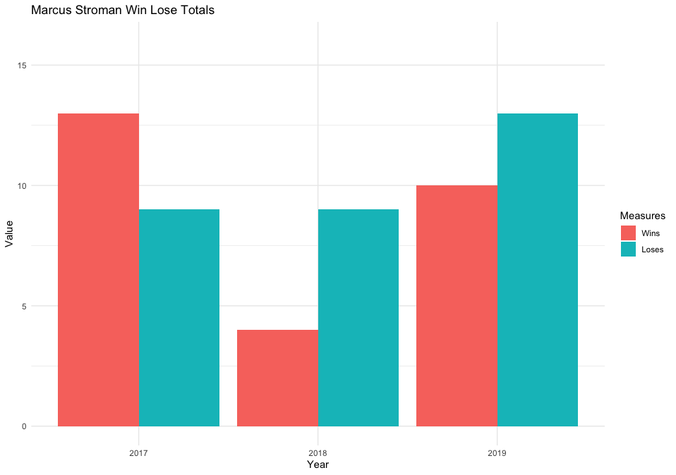
Figure 12: Visualizes the Win Lose Record for Marcus Stroman between 2017-2019

Figure 13: Noah Syndergaard’s Appearances
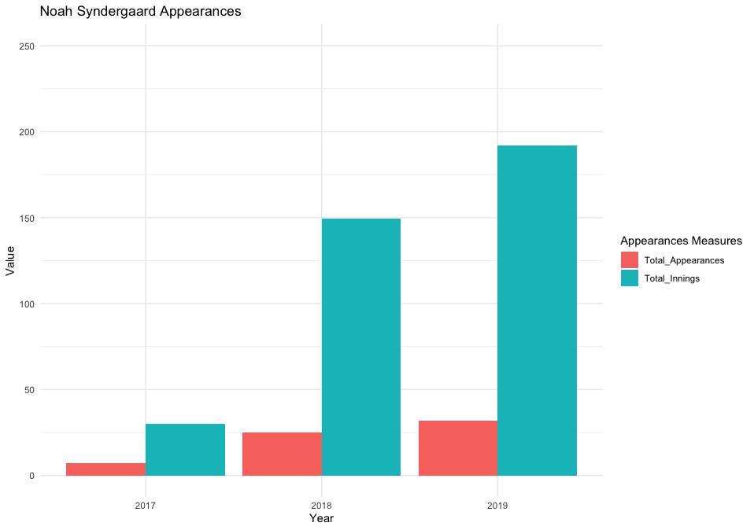
Figure 13: Visualizes the total number of appearances and total number of innings pitched by Noah Syndergaard between 2017 and 2019.

Figure 14: Noah Syndergaard’s Performances
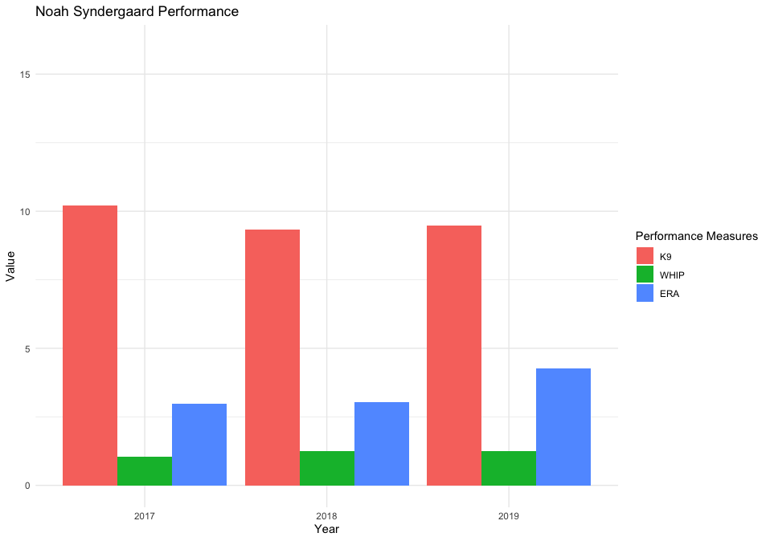
Figure 14: Visualizes the performance statistics including K/9, WHIP, and ERA for Noah Syndergaard between 2017-2019

Figure 15: Noah Syndergaard’s Pitch Breakdown
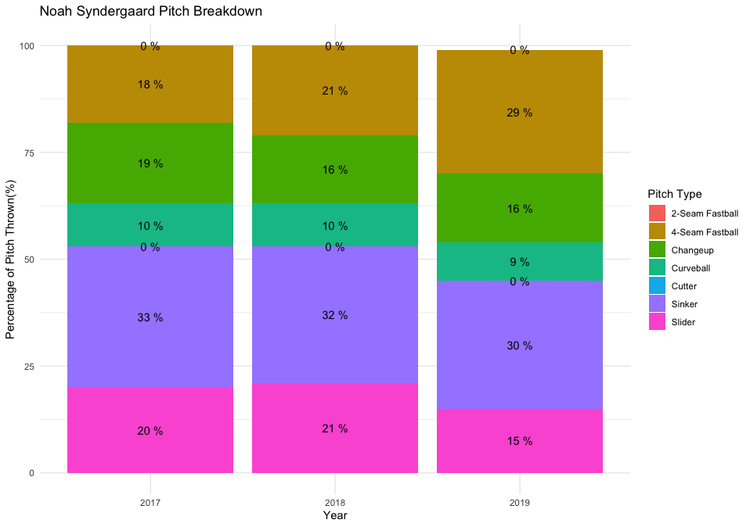
Figure 15: Visualizes the breakdown of pitches thrown by Noah Syndergaard between 2017-2019

Figure 16: Noah Syndergaard’s Win Lose Record
Figure 16: Visualizes the Win Lose Record for Noah Syndergaard between 2017-2019

Figure 17: Seth Lugo’s Appearances
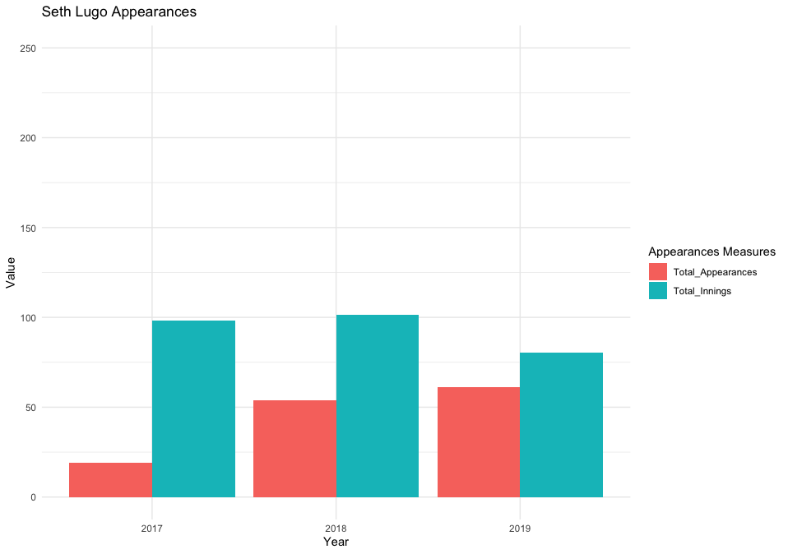
Figure 17: Visualizes the total number of appearances and total number of innings pitched by Seth Lugo between 2017 and 2019.

Figure 18: Seth Lugo’s Performance
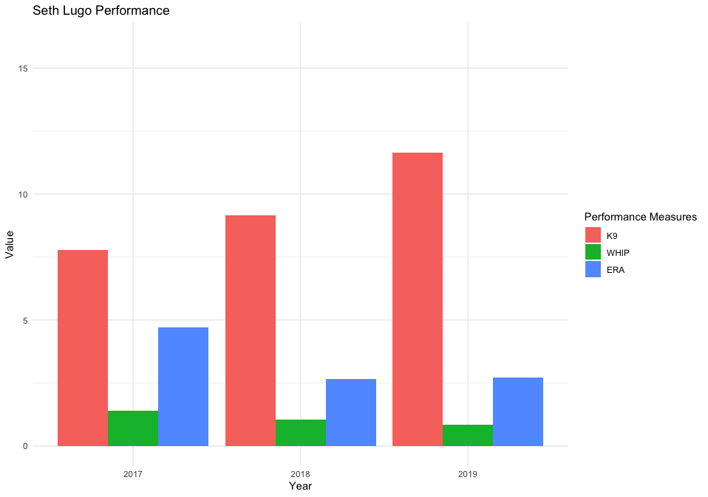
Figure 18: Visualizes the performance statistics including K/9, WHIP, and ERA for Seth Lugo between 2017-2019

Figure 19: Seth Lugo’s Pitch Breakdown
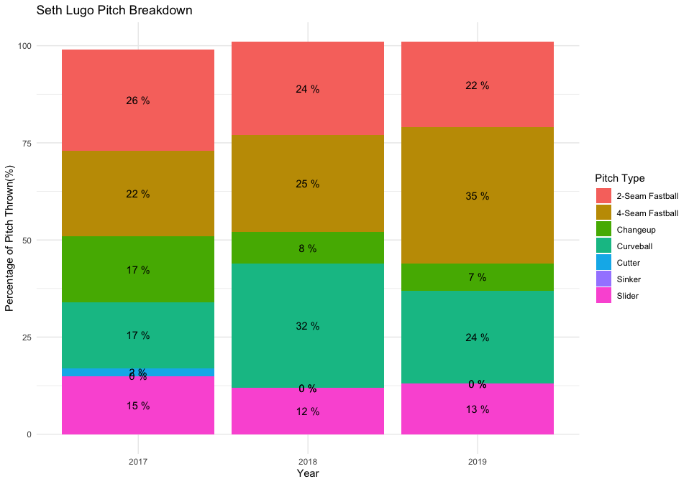
Figure 19: Visualizes the breakdown of pitches thrown by Seth Lugo between 2017-2019

Figure 20: Seth Lugo’s Win Lose Record
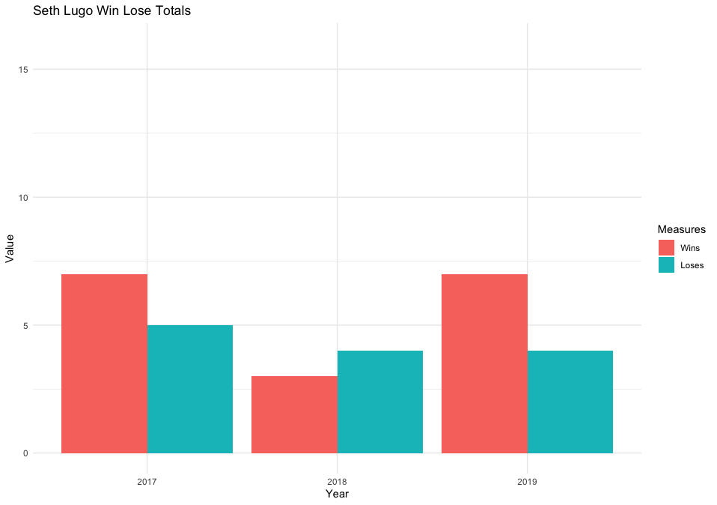
Figure 20: Visualizes the Win Lose Record for Seth Lugo between 2017-2019

Figure 21: Distribution of Pitches Swung At
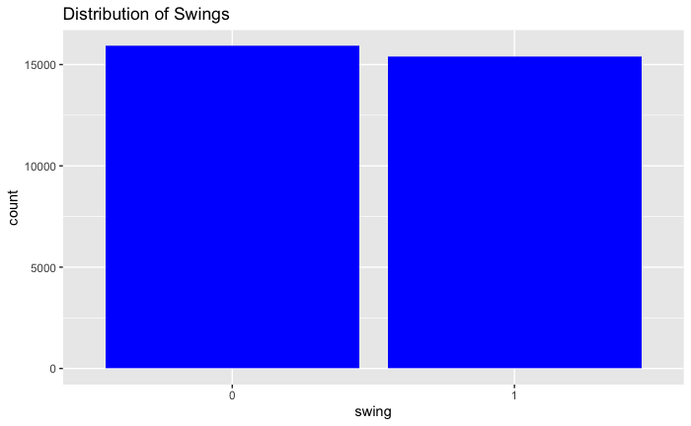

Figure 21 the distribution of swings and no swings. The swing variable was created and includes swinging strikes, fouls, foul tips, and hits.

Figure 22: Distribution of Pitches Swung At by Pitcher and Pitch Type

Figure 22 the distribution of swings by pitch type and pitcher. The swing variable was created and includes swinging strikes, fouls, foul tips, and hits.

Preprocessing Dataset Manipulation
Dataset was relatively clean and required very little cleansing. The following items were addressed with the data before it was able to be analyzed.
- Missing Values
There were no missing values to address in dataset.
- Most preprocessing was done for each particular model. As such, preprocessing specific to the model will be documented under the Model description.
- “Swing Variable”: An additional variable called “Swing” was created to identify when a swing had occurred based on the values of other fields. This was based off the “description” of each pitch.
- “Speed Factor”: An additional variable called “Speed Factor” was created to classify a “Fastball” vs an “Off-speed” pitch. This was created based on the “Pitch Type” variable.
- “Strikeout Recorded”: An additional variable called “Strikeout Recorded” was created to classify if the pitch resulted in a strikeout. This was based on the “events” variable.
- “Walk Recorded”: An additional variable called “Walk Recorded” was created to classify if the pitch resulted in a walk. This was based on the “events” variable.
- “Hit Recorded”: An additional variable called “Hit Recorded” was created to classify if the pitch resulted in a hit. This was based on the “events” variable.
- “Homerun Recorded”: An additional variable called “Homerun Recorded” was created to classify if the pitch resulted in a homerun. This was based on the “events” variable.
- “Outs After Pitch”: An additional variable called “Outs After Pitch” was created to identify the number of outs there were after each pitch. This was created based on the “events” and “Outs When Up” variables.

Models:

Model 1: Naïve Bayes – For All Data in Dataset

Model 1: Confusion matrix for Naïve-Bayes model of all pitchers predicting swings. Variables used: Player name, zone, balls, strikes, stand, pitch type, release speed, and swing (including swinging strikes, fouls, foul tips, and hits). Cross validated ten times.

Model 2: Naïve Bayes – For Jacob deGrom

Model 2: Confusion matrix for Naïve-Bayes model of Jacob deGrom predicting swings. Variables used: Player name, zone, balls, strikes, stand, pitch type, release speed, and swing (including swinging strikes, fouls, foul tips, and hits). Cross validated ten times.

Model 3: Naïve Bayes – For Marcus Stroman

Model 3: Confusion matrix for Naïve-Bayes model for Marcus Stroman predicting swings. Variables used: Player name, zone, balls, strikes, stand, pitch type, release speed, and swing (including swinging strikes, fouls, foul tips, and hits). Cross validated ten times.

Model 4: Naïve Bayes – For Seth Lugo

Model 4: Confusion matrix for Naïve-Bayes model for Seth Lugo predicting swings. Variables used: Player name, zone, balls, strikes, stand, pitch type, release speed, and swing (including swinging strikes, fouls, foul tips, and hits). Cross validated ten times.

Model 5: Naïve Bayes – For Edwin Diaz

Model 5: Confusion matrix for Naïve-Bayes model for Seth Lugo predicting swings. Variables used: Player name, zone, balls, strikes, stand, pitch type, release speed, and swing (including swinging strikes, fouls, foul tips, and hits). Cross validated ten times.

Model 6: Naïve Bayes – For Noah Syndergaard

Model 6: Confusion matrix for Naïve-Bayes model of Noah Syndergaard predicting swings. Variables used: Player name, zone, balls, strikes, stand, pitch type, release speed, and swing (including swinging strikes, fouls, foul tips, and hits). Cross validated ten times.

Model 7: Elbow Chart
Model 7: Elbow chart to determine the optimal number of clusters. Six clusters were chosen for this analysis.

Model 8: K-Means – Euclidean Distance

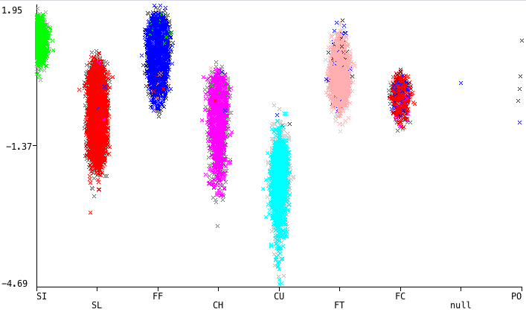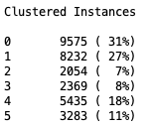

Model 8: Pitch type plotted against release speed using Euclidean distance and six clusters. Variables used: pitch type, zone, release speed, release spin rate, release pos x and z, pfx_x, pfx_z, plate_x, plate_z. All points except for pitch type and zone were standardized by taking that value’s Z-Score.

Model 9: K-Means – Manhattan Distance

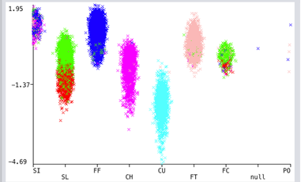
Model 9: Pitch type plotted against release speed using Manhattan distance and six clusters. Variables used: pitch type, zone, release speed, release spin rate, release pos x and z, pfx_x, pfx_z, plate_x, plate_z. All points except for pitch type and zone were standardized by taking that value’s Z-Score.

Model 10: K-Means

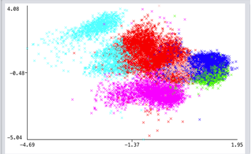

Model 10: Release speed plotted against release spin rate using Euclidean distance and six clusters. Variables used: pitch type, zone, release speed, release spin rate, release pos x and z, pfx_x, pfx_z, plate_x, plate_z. All points except for pitch type and zone were standardized by taking that value’s Z-Score.

Model 11: Farthest First

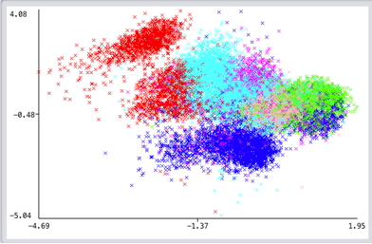
Model 11: Release speed plotted against release spin rate using farthest first algorithm and six clusters. Variables used: pitch type, zone, release speed, release spin rate, release pos x and z, pfx_x, pfx_z, plate_x, plate_z. All points except for pitch type and zone were standardized by taking that value’s Z-Score.

Model 12: Pitch Distribution – Noah Syndergaard

Model 12: Visualizes the release distribution for pitcher Syndergaard. The visual is presented from catcher/batter’s perspective. From here, pitches were separated into fastball or off-speed type pitches and SVM models may be trained.

Model 13: SVM – Noah Syndergaard – Polynomial Kernel
Model 13 : Visualizes the results of SVM model on the Syndergaard pitch dataset with a polynomial kernel and a cost of 100. 1 represents fastball pitches and -1 represents off-speed pitches.

Model 14: SVM – Syndergaard – Radial Kernel
Model 14: Visualizes the results of SVM model on the Syndergaard pitch dataset with a radial l kernel and a cost of 100. 1 represents fastball pitches and -1 represents off-speed pitches.

Model 15: SVM – Syndergaard – Linear Kernel
Model 15: Visualizes the results of SVM model on the Syndergaard pitch dataset with a linear l kernel and a cost of 100. 1 represents fastball pitches and -1 represents off-speed pitches.

Model 16: RPart Decision Tree for pitch prediction for Seth Lugo
Model 16: Visualizes the prediction of pitches from Seth Lugo using the summary count (ahead, behind or even in the count), number of outs, game score (winning, losing or tied) and inning.

Model 17: RPart Decision Tree for pitch based on pitch speed and zone for Seth Lugo

Model 17: Visualizes the prediction of pitch based on the speed and zone from Seth Lugo. Additionally, the confusion chart illustrates the accuracy rate.

Model 18: RPart Decision Tree for pitch speed and zone for Noah Syndergaard
Model 18: Visualizes the prediction of pitch based on the speed and zone from Noah Syndergaard.

Model 19: RPart Decision Tree for pitch speed and zone for Jacob deGrom
Model 19: Visualizes the prediction of pitch based on the speed and zone from Jacob deGrom.

Model 20: RPart Decision Tree for pitch speed for Jacob deGrom

Model 20: Visualizes the prediction of pitch based on the speed and zone from Jacob deGrom.

Model 21: RPart Decision Tree for pitch for Stroman

Model 21: Visualizes the prediction of pitch based on the speed and zone from Jacob deGrom.

Model 22: RPart Decision Tree for pitch and confusion table for Marcus Stroman
Model 22: Visualizes the prediction of pitch based on the speed and zone from Marcus Stroman.

Model 23: RPart Decision Tree for pitch and confusion table for Edwin Diaz
Model 23: Visualizes the prediction of pitch based on the speed from Edwin Diaz.

Model 24: RPart Decision Tree for pitch and confusion table for Edwin Diaz

Model 24: Visualizes the prediction of pitch based on the speed and zone from Edwin Diaz.

Model 25: Associated Rule Mining - Confidence
Model 25: Visualizes the top 10 Associated Rules sorted by Confidence for Edwin Diaz

Model 26: Associated Rule Mining - Lift
Model 26: Visualizes the top 10 Associated Rules sorted by Lift by Marcus Stroman

Model 27: Associated Rule Mining - Support
Model 27: Visualizes the top 10 Associated Rules sorted by Support by Jacob deGrom

Results

Model 1: Naïve Bayes – For All Data in Dataset

The first model used the data set with all of the pitchers combined to try and predict whether there would be a swing. This model returned 69.2% accuracy.

Model 2: Naïve Bayes – For Jacob deGrom

The deGrom data model resulted in a 68.9% accuracy.

Model 3: Naïve Bayes – For Marcus Stroman

The Stroman model had an accuracy of 70.5% accuracy.

Model 4: Naïve Bayes – For Seth Lugo

Lugo’s model had a 70.2% accuracy.

Model 5: Naïve Bayes – For Edwin Diaz

The Diaz model yielded a 69.2% accuracy.

Model 6: Naïve Bayes – For Noah Syndergaard

The Syndergaard model gave a 68.2% accuracy.

An application of this would be to run different scenarios through these models to predict if a batter will swing at a specific pitch. As an arbitrary example, if Stroman needs a left-handed batter to swing when the count is 2-2 then he should pitch a 90 mph fastball to zone 8. This could also work for the reverse scenario. If Diaz needs his batter to not swing at a pitch and the count is 1-1 and the batter is right handed, he should try to pitch a slider to zone 10.

The accuracy range of these models (68.2%-70.5%) does not give the Mets pitchers an incredible competitive advantage over their batters and probably does not offer much more information than they already know going into a game. But, if a subset of batters of a specific team were used on these models, it could help with some strategical decision making.

Model 7: Elbow Chart

For this analysis, either five or six clusters will work based on the above chart. Six clusters is where the graph really starts to level off, so six clusters will be used for this analysis.

Model 8: K-Means – Euclidean Distance

Four of the clusters share the same zone for their centroids. Zone 14 is the most common zone in this data having 6,549 pitches crossing this zone. The next most-frequent is zone 11 with 3,736 pitches. Another thing to note is that 31% of the observations landed in cluster 0 which is centered around pitch type FF. This pitch type is the most frequent pitch thrown in this dataset with 9,615 pitches.

The clusters are really long showing that each pitch can have a range of speeds, but there is not too much crossover between pitch types. Each cluster is doing a pretty good job of retaining its pitch type.

Model 9: K-Means – Manhattan Distance

The Manhattan distance measure does not do as good of a job separating pitches by pitch type as illustrated by the visual below; however, one interesting thing about the slider (SL) and cutter (FC) pitches is that they are so similar that it is hard to determine which is actually thrown. In the illustration below, the clustering algorithm shows that these two pitches are made up of a mixture of both cluster 1 and cluster 2. This shows that the similarity of the attributes of these two pitches makes it hard to determine exactly which pitch is thrown.

Model 10: K-Means – Euclidean Distance

Clusters 1, 3, and 5 are pretty well defined with only a few observations within this cluster being from outside clusters. Cluster 0 is also fairly well defined, although it does overlap with cluster 2 quite a bit. Clusters 2 and 4 are not as well defined as they are crowded by the other clusters. It is easy to see that there are many observations from other clusters breaking into the boundaries of these clusters. These clusters show that many of the observations can be grouped together based on release speed and release spin rate which makes sense as different pitch types need to have different speeds and spin rates to get the ball to do what the pitcher wants.

Model 11: Farthest First

Although the observations were grouped together in different cluster numbers using this algorithm, the overall geometry of the clusters is very similar to the simple K means algorithm with the exception of cluster 5. This cluster is more prominent in the farthest first analysis than in the simple K means in which it is covered by another cluster. Here, it has a more well defined boundary with cluster 3 and is not as overwhelmed by observations that belong to other clusters.

Model 12: Pitch Distribution – Noah Syndergaard

Release distribution is varied enough that batters may indeed be able to see the differences in release position based on Pitch Type.

Model 13: SVM – Noah Syndergaard – Polynomial Kernel

 | -1 | 1
-1 | 1205 | 1404
1 | 709 | 2644

Accuracy: 64.56% | Pos Pred Value: 46.19% | Neg Pred Value: 78.85%

Above we see the prediction table and accuracy of the polynomial kernel with a cost of 100 on the Syndergaard pitch dataset.

Model 14: SVM – Syndergaard – Radial Kernel

 | -1 | 1
-1 | 924 | 1685
1 | 436 | 2917

Accuracy: 64.42% | Pos Pred Value: 35.42% | Neg Pred Value: 87.00%

Above we see the prediction table and accuracy of the radial kernel with a cost of 100 on the Syndergaard pitch dataset.

SVM – Syndergaard – Linear Kernel Results

 | -1 | 1
-1 | 1169 | 690
1 | 1440 | 2663

Accuracy: 64.27% | Pos Pred Value: 44.81% | Neg Pred Value: 79.42%

Above we see the prediction table and accuracy of the linear kernel with a cost of 100 on the Syndergaard pitch dataset.

Additional Analysis for Models 3.12 – 3.15

SVM – Syndergaard – Cost Calibration
Accuracy by Cost | 50 | 100 | 150
Polynomial | 64.63 | 64.56 | 64.51
Radial | 64.48 | 64.42 | 64.53
Linear | 64.27 | 64.27 | 64.26

Above we see the accuracy results for each tested kernel by cost. Minimal difference in accuracy by cost is observed.

In reviewing available data on the specific attributes of our pitching staff, we hypothesized that a pitcher’s release may be used by opponents to pre-judge the relative speed of the pitch and thus calibrate their swing accordingly. Specifically, the point in space of the pitcher’s arm at which the ball is released may provide an indication of whether the pitch will be a fastball or an off-speed pitch. If this hypothesis were to prove true, it would represent a considerable advantage to opposing batters and would require correction.

Focusing on Syndergaard, we can see that the release distribution is varied enough that batters may indeed be able to see the differences in release position. Further, in viewing the scatterplot, we can see that fastball pitches appear to have a wider range than off-speed pitches. This is our first clue that release position may - at least to some degree – indicate the speed factor of a pitch.

However, upon applying our SVM models, it’s apparent that the predictability of speed factor by release position is limited. We find that the polynomial kernel with a low cost produces the best accuracy of 64.63%. The other kernels and respective costs do not perform significantly worse, though. We see a very limited range in accuracy when selecting different kernels and assigning different costs.

Applying these same models and methods to the other pitchers, our results are not much better. In fact, the highest observed accuracy is obtained for Seth Lugo at 65.87%. These results indicate strongly that predicting a pitch speed of fastball or off-speed would be extremely difficult, if not impossible for a batter. If our advanced analytical models are performing so poorly given large processing power and plenty of time, it’s difficult to imagine a human batter doing much better.

To test this hypothesis, support vector machine (SVM) models were deployed for all five pitchers represented in our dataset. SVM is an ideal model for this scenario as it allows us to easily classify a binary result (fastball or offspeed) against the pitcher’s release position (X and Z).

Given the extremely brief time that elapses during a pitch event, in order for a batter to gain a competitive advantage from a release position indicator, we would need our model to return a very high accuracy. Otherwise we can assume that the batter would not have sufficient time to discern the release and calibrate their pitch. In other words, the tell must be obvious and consistent.

Model 16: RPart Decision Tree for pitch prediction for Seth Lugo

Lugo is a reliever with a wide range of pitches who comes in in the later innings. Looking for pitch prediction based on the count, if Lugo is behind (balls > strikes) there is a 33% chance that he throws a 2-seam fast ball and a 27% chance that he throws a 4-seam fast ball (60% chance he throws a fast ball). If he is even in the count (balls = strikes), there is a 53% (20% 2-seam and 33% 4-seam) chance that he throws a fastball. The other pitch to watch for is a curveball (27% chance). If Lugo is ahead in the count (which is usually is at 5=43% of the time) the top 3 pitches are a fast ball (2-seam at 22% and 4-seam at 23%) combined for 43% but the curveball is the next pitch to watch for at 30%. Difficult to make a prediction here.

Model 17: RPart Decision Tree for pitch based on pitch speed and zone for Seth Lugo

While the overall model does not have a very high accuracy rate, 61.88% there are some observations that might add some insight. In anticipating the pitch, if Lugo throws a curveball, there is a very high likelihood that it will be slower than 85mph. It is highly likely that his sliders will come in between 80 and 90. The 2-seam and 4-seam fast balls are coming in over 90mph. about 21% of the fastballs are low.

Model 18: RPart Decision Tree for pitch speed and zone for Noah Syndergaard

While this model is not the most accurate at predicting pitches (63.22%), again there may be some insights in the data. When Syndergaard is throwing a pitch between 85 and 95, it is highly likely that it is a slider with a slight chance that it could be a changeup. Slower than 85mph, it is highly likely that the pitch is a curveball.

When throwing the heat, it will be either his slider or his 2-seam fastball. The 2-seam fastball is usually in the strike zone (zones 1-9) while his slider seems to have more variability and will usually be low.

Model 19: RPart Decision Tree for pitch speed and zone for Jacob deGrom

deGrom is a starting pitcher; pitching in the early innings. He essentially has 5 pitches; 3 are fast balls (2-seam and 4-seam fast balls and a slider. The other two pitches are a changeup and a curveball. The models looking for tendencies based on count, batter stance, base runners, outs or score did not identify anything.

Any of deGrom pitches can be low (outside of the strike zone). Low on the right side is generally the slider while low and left is his changeup.

Model 20: RPart Decision Tree for pitch speed for Jacob deGrom

This model is the highest of the predictive models at 70.13% for predictive accuracy. Both of the 2-seam and 4-seam fastballs are typically over 95mph but may go as slow as 90mph. His changeup and sliders will travel between 85mph and 95mph. His curveball travels between 70 mph and 85mph.

Model 21: RPart Decision Tree for pitch for Stroman

Stroman is a starter pitching primarily in the earlier innings. He essentially has 6 pitches: 2-seam fastball, 4-seam fastball, slider, cutter, changeup and curveball.

When Stroman in ahead in the count (73% of the time), he throws faster. His pitch variation is about the same regardless of the count except that he throws more 2-seam fastballs and fewer sliders.

Model 22: RPart Decision Tree for pitch and confusion table for Marcus Stroman

This model has an accuracy of predicting pitch names of 73.27%. His 2-seam fastball is his consistently fastest pitch, of the 46% of pitches over 90mph, 82% of these pitches are the 2-seam fastball. Of the remaining 54% of the pitches slower than 90mph, 52% are his slider with a smattering of the other 7 pitches including his fastballs.

Model 23: RPart Decision Tree for pitch and confusion table for Edwin Diaz

Diaz is a reliever or closer only coming in the late innings. He essentially throws only 2 pitches, the 4-seam fastball and the slider. He does throw 3 other pitches (2-seam fastball, sinker and a changeup) but they combine for less than 0.3% of his pitches.

Diaz doesn’t throw many pitches, his fastball is consistently between 90mph and 100mph and his slider travels in at 85mph to 90mph.

Model 24: RPart Decision Tree for pitch and confusion table for Edwin Diaz

This prediction model has an accuracy of 96.44%! Well, with only 2 pitches, I could probably have done his on paper. This model indicates that 100% of the pitches over 95mph are his 4-seam fastball. The other pitches are slower than 95mph.

Model 25: Associated Rule Mining - Confidence

While many of the rules that were identified were interesting, such as there is an 99.02% chance that Edwin Diaz will throw a slider up to 92mph in the ninth inning when the score is tied, it is not specific enough to reliably use this prediction to give the opposing batter an advantage. Below is a visual representation of Edwin Diaz throwing a Slider.
Model 25: Visualizes the top 10 Associated Rules sorted by Confidence for Edwin Diaz

Model 26: Associated Rule Mining - Lift

While many of the rules that were identified were interesting, such as there is an 84.32% chance that Marcus Stroman will throw a 2-seam fast ball between 91 mph and 95mph to a right handed batter when there is no one on base and the score is tied, it is not specific enough to reliably use this prediction to give the opposing batter an advantage. Below is a visual representation of Marcus Stroman’s 2-Seam Fastball Chart.

Model 27: Associated Rule Mining - Support

While many of the rules that were identified were interesting, such as there is an 87.22% chance that Jacob deGrom will throw a 4-seam fast ball between 96mph and 101mph to a left handed batter when the count is even, it is not specific enough to reliably use this prediction to give the opposing batter an advantage. It is noticeable that the rules are vague across the board. Below is a visual representation of Jacob deGrom throwing a 4-Seam Fastball.

Conclusion

The advanced data modeling contained in this report demonstrated that opposing teams would not be able to leverage these models in a similar fashion and gain a competitive advantage over our pitching staff. While the classification models had some success and insight the results could not be produced with enough confidence for us to say it would definitely help an opposing team. This team believes that additional analysis could be helpful to ensure that this statement could be made with even more confidence.

One factor believed to be a contributor to our models not being able to provide a competitive advantage is the fact that they are being utilized against professional caliber players. This believe stems from the understanding that for an athlete to reach this level and perform at the level necessary to stay there requires a level of expertise. It would be interesting to see if these models would provide a completive advantage if deployed against players of lesser ability.

Furthermore, the results of the analytics in this report reaffirmed the idea that analytics is best used as a complementary component to traditional resources such as managing, coaching, and scouting. While analytics has grown and developed a strong position in baseball, it could never take the place of experience.

